Diana McEntee

Dr. Scales

EDLS 307-002

4 September 2018

Arts Integrated Book Flood #1

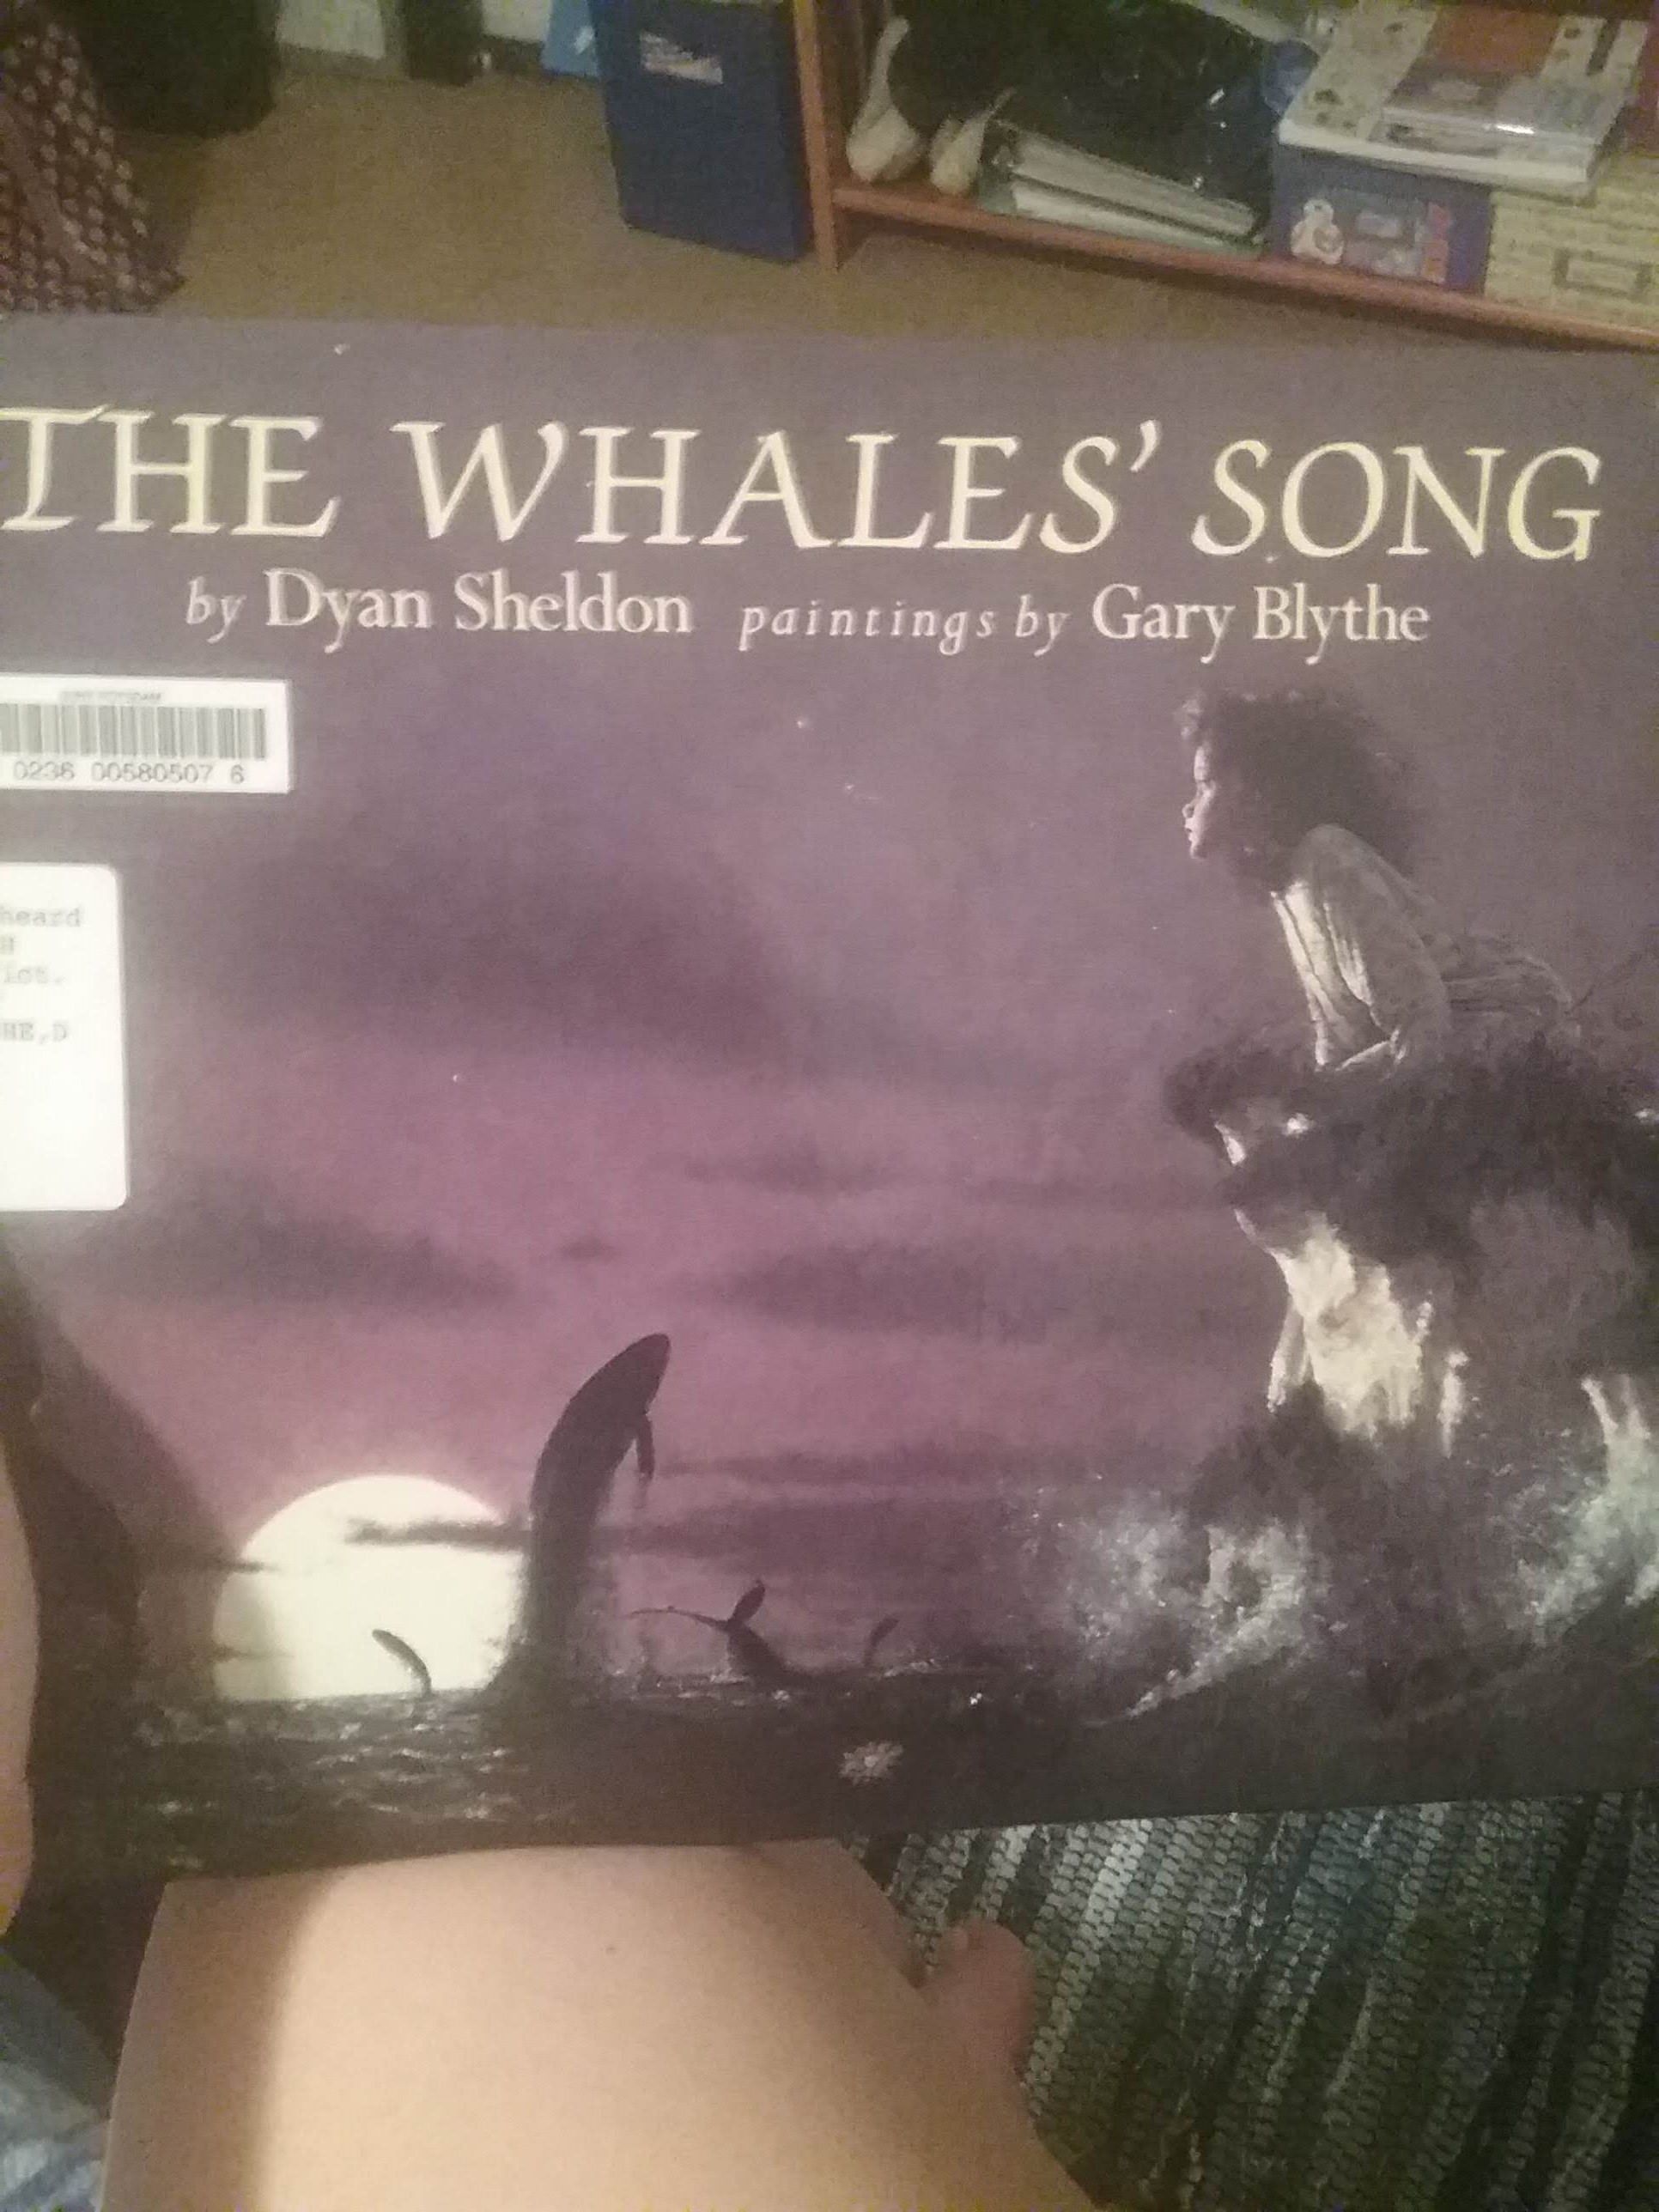

**“The Whales’ Song” 1991, Children’s Fiction**

**Author:** Dyan Sheldon **Illustrator:** Gary Blythe

**Intended Audience:** Elementary. There are many pictures supplementing the story. The main character is a young girl. The vocabulary is appropriate for the elementary age group.

**Synopsis:** A little girl, Lilly, is told a story by her grandmother about the whales living in the ocean close to their home. She tells Lilly that the whales would sing their special song for her in return for a gift. Lilly’s great-uncle brings a dark cloud into the plot when he enters and exclaims that grandmother’s stories are nonsense. There’s a difference in opinion between his views that whales are for eating and her views that they are magical creatures. Lilly later dreams about the whales in her sleep. The next morning, she attempts to lure the whales to the pier with a yellow flower with no success. That night she goes to sleep only to be awoken by unfamiliar sounds. She runs to the pier to find many whales leaping and singing in the night. The story concludes with her realization that the whales seemed to be calling her name.

**Connections:** The plot revolves around the mysterious, magical nature of the elusive whale song. The qualities of the song are never described; however, the night setting contributes a sense of the possibilities of the song’s sound. (Perhaps like a nocturne?) The reader’s imagination is welcomed to envision the character of the song. Conflict between the grandmother and great-uncle present tension that could also be present in music. This tension is gratefully relieved upon the conclusion of the story when the whales reveal themselves. The colors chosen in the illustrations set a particular mood encompassing the serenity and mysteriousness of nature—a task that music too can accomplish.

**AI Toolbox Seed Strategy:** Music Response Journal, pg. # 524. “The Whales’ Song” could be a supplement to a music response journal. I would read the book with the class then play recordings of various whale calls. Students would then be prompted to identify musical characteristics found in the calls such as pitch, dynamics, and texture. Then they would be prompted to identify musical selections that bear similarities to the “a whale’s song.” Finally, students would be prompted to identify any elements of the text that could have been inspired by whale calls or similar music.

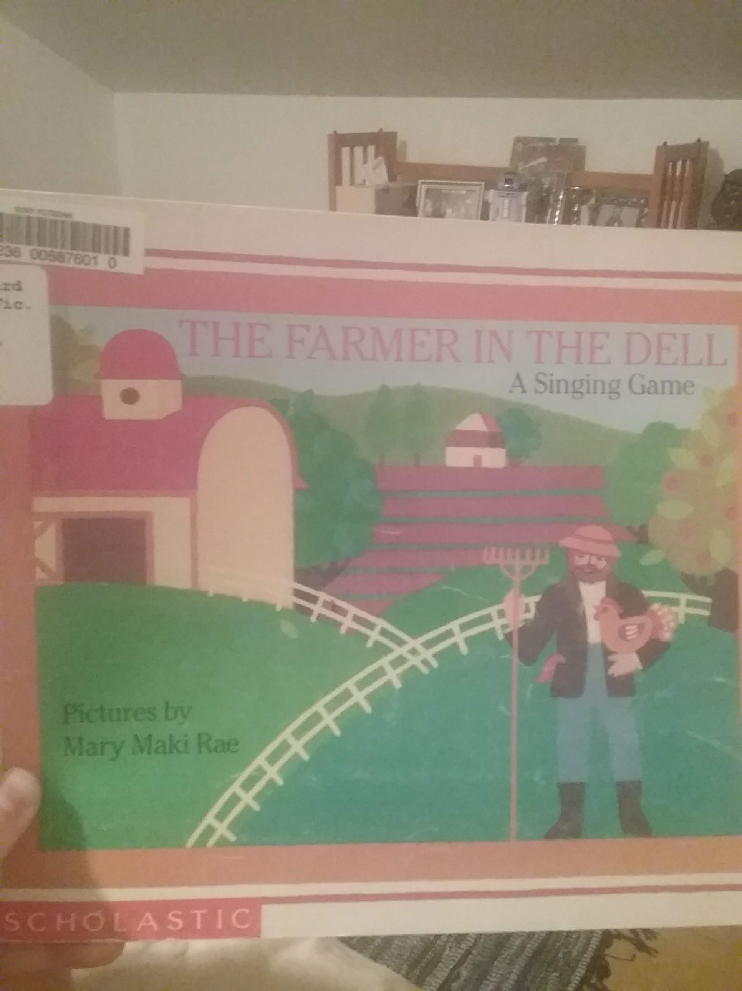

**“The Farmer in the Dell: A Singing Game.” 1988, Children.**

**Author:** Unknown-1820's Germany **Illustrator:** Mary Maki Rae

**Intended Audience:** Early Elementary.

**Synopsis:** Text is a singing game originating from the Middle Ages. The words outline the progression of the game. The illustrations support the text.

**Connections:** The book follows the text for the song “The Farmer in the Den” thus presenting visuals as the students grasp the text to the song. The colors chosen for the illustrations are vibrant and lovely reflecting the Allegro tempo of the song and game. The characters being sung about are found on the same page of the text. Also, the score of the music is supplied in the back of the book.

**AI Toolbox Seed Strategy:** Energizer, pg. # 511: Book can be read first to teach students lyrics to song. Singing game can then be played as a brief interjection to class. Game allows students to release energy thereby regaining focus while still utilizing singing voices.

Arts Integrated Book Flood 2

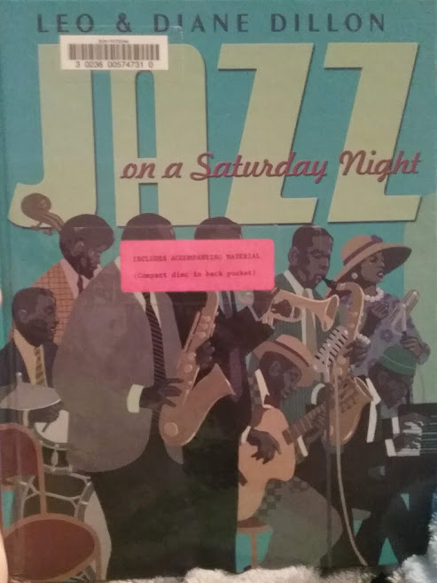

***Jazz on a Saturday Night, 2007*, Historical Children’s Fiction**

**Authors and Illustrators:** Leo and Diane Loomans

**Intended audience:** This book could suit both elementary and middle school aged students. The vocabulary is simple enough to suit a younger audience. However, the exploration of key figures in jazz history could be expanded upon in a middle school classroom. The illustrations prove to be enriching enough to captivate a wide age range.

**Synopsis:** An audience of well-dressed, hardworking folks awaits a special musical treat. They have come for an evening of jazz. Each page introduces a different famous jazz musician and their instrument. While key jazz contributors are learned, the complex and enriching nature of the music genre is also learned. An accompanying CD is provided that includes selections from all of the jazz artists mentioned in the narrative.

**Connections:** This text correlates beautifully with lessons in America’s history, especially from the 1940’s through 1950’s. Jazz weaves throughout America’s culture in this time period, and this book could serve as a connection between music, culture, and African American rights. Literary elements such as rhyme and imagery are also ingrained into the text. The warm, inviting color palate of the illustrations accurately portray the ambiance of such Saturday night jazz performances that would have occurred during the 1940’s-1950’s.

**Seed Strategy:** History through Music pg. 532. Students would be introduced to the history and culture of jazz through exposure to this book and selections from the accompanying CD. Then students would be tasked with choosing and researching one jazz artist mentioned in the book. The repertoire and style of the artists would be delved into further by individual students and then presented to the class. Meanwhile, historical context would be taught to students as they complete their projects in jazz history.

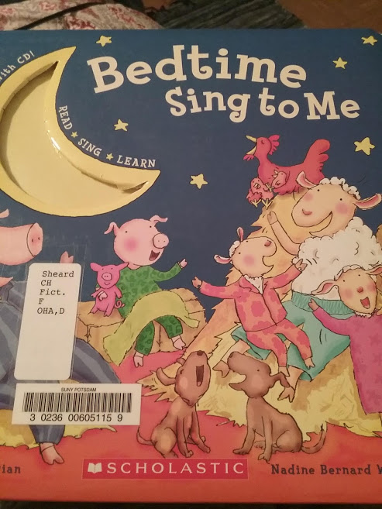

***Bedtime Sing to Me,* 2009, Children’s Musical Score/Singing Book**

**Author:** Diane C. Ohanesian **Illustrator:** Nadine Bernard Westcott

**Intended Audience:** Early Elementary. The songs contained within this book are intended for younger children. Also, their melodic and rhythmic difficulty are well suited for a younger audience.

**Synopsis:** This book is a collection of popular children songs. The lyrics are presented alongside illustrations directly related to the song. A CD is included that corresponds to the songs, so the reader learns the tune aurally instead by reading music notation.

**Connections:** This volume of songs offers an approach to music education directly through literature and visual art. Children are not concerned with the nitty gritty details of making music, such as note reading. Instead, they are concerned with basic literacy skills and connecting the illustrations to the meaning of the song. However, the motive behind the pages is to introduce children to a suitable canon of music.

**Seed Strategy:** Song Scavenger Hunt, page # 523. The versatility and diversity of the songs within this book would be suitable for an activity/lesson in which students categorize songs based on content or language patterns. Students can learn to recognize rhyming words, repeated sentences (patterns), and alliterations through analysis of the lyrics.